

A project report on

IOT BASED SECURITY SYSTEM WITH E-MAIL ALERT

J^{th} COMPONENT

PROJECT SUBMITED
BY

DURAIRAJ. K(17BCA0073)

ABISHEK R. K(17BCA0103)

PRITHIVIRAJ P(17BCA0129)

VIGNESH R(17BCA0130)

Abstract:

This is the IOT based project named ‘Security System with E-mail Alert’. This project mainly focus on Securities for shops and other places. The Main theme of the project is when the motion is triggered by the camera, that means when someone moved inside the shop or some other places, then the camera will detect the motion and the raspberry pi instantly sends the mail with alert to user or the owner. The is mostly used on night time in the closed shops.

Components required:
* Raspberry pi
* Memory card
* Pi Camera and web Camera
* Power Bank

Raspberry pi Model 3b+:
- The Raspberry Pi is a low cost, credit-card sized computer that plugs into a computer monitor or TV, and uses a standard keyboard and mouse. It is a capable little device that enables people of all ages to explore computing, and to learn how to program in languages like Scratch and Python.
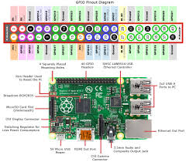

Memory Card or (SD):
- Configure the image (SD card) by following our guide Setup SD Card. Just substitute the recommended Raspbian image download with the MotionEYE image you chose earlier.
- Open a browser on your computer (or tablet, or phone)
- for example, replacing that IP address with the IP address of your device, into the address bar. If all goes well, you will reach the initial screen of motionEye OS.

Pi Camera:
- The Pi camera module is a portable light weight camera that supports Raspberry Pi. It communicates with Pi using the MIPI camera serial interface protocol. It is normally used in image processing, machine learning or in surveillance projects. It is commonly used in surveillance drones since the payload of camera is very less. Apart from these modules Pi can also use normal USB webcams that are used along with computer.
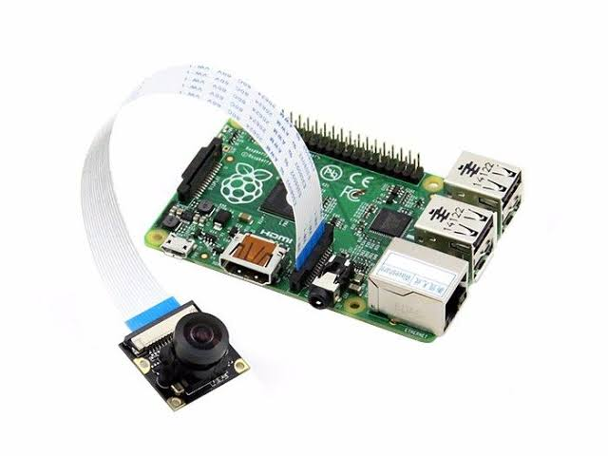
Features of Pi Camera:
* 5MP colour camera module without microphone for Raspberry Pi
* Supports both Raspberry Pi Model A and Model B
* MIPI Camera serial interface
* Omnivision 5647 Camera Module
* Resolution: 2592 * 1944
* Supports: 1080p, 720p and 480p
* Light weight and portable (3g only)

Web Camera:
- RPi Cam Web Interface is a web interface for the Raspberry Pi Camera module. It can be used for a wide variety of applications including surveillance, dvr recording and time lapse photography. It is highly configurable and can be extended with the use of macro scripts.
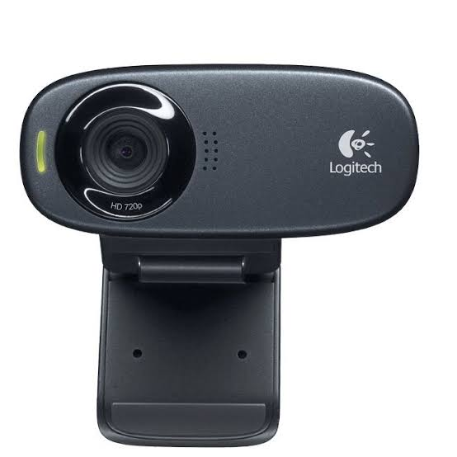

Power Bank:
- Our new updated 20,000mAh power bank from ModMyPi is the most powerful portable solution for keeping your Raspberry Pi powered anywhere! Boasting a massive 20,000mAh power capacity and dual 5V 2.4A output USB ports, this portable charger has enough juice to keep your Raspberry Pi's powered for extended hacking periods.
- The Raspberry Pi is a low cost, credit-card sized computer that plugs into a computer monitor or TV, and uses a standard keyboard and mouse. It is a capable little device that enables people of all ages to explore computing, and to learn how to program in languages like Scratch and Python.

What is MotionEyeOS?
MotionEyeOS is a Linux distribution that turns your single-board computer into a video serveillance system. The MotionEyeOS supports the following devices:
- Raspberry Pi (all versions);
- Banana Pi;
- Odroid C1/C1+, Odroid C2, Odroid XU4;
- Pine A64/A64+.

MotionEyeOS Features
MotionEyeOS is the perfect solution to build your own surveillance system because it is simple to install and has a web-based, user-friendly interface that is responsive in practically any browser.
It supports most USB cameras, Raspberry Pi camera modules, and IP cameras. Additionally, it brings other useful features when it comes to a surveillance system:
- Motion detection with email notifications
- You can set set a working schedule
- Take still images
- Store your files in SD card, USB drive, or upload your files to Google Drive or Dropbox
- Access your media files through FTP server or SFTP server

Downloading the OS Image
Choose the right image for your device: MotionEyeOS releases page. If you’re using the Raspberry Pi 3, choose motioneyeos-raspberrypi3-xxxxxxxx.img.gz.

Writing the Image
Next, extract the image from the .zip folder. Then, you can use win32diskimager or Etcher, to write the image onto the SD card.
We’re going to use Etcher. If you don’t have Etcher installed, you can click here and install it on your computer.
With the microSD card formatted, and connected to your computer, open Etcher. Select the image you’ve get previously, select your microSD card, and click Flash!

Installing MotionEyeOS
To install MotionEyeOs in your Raspberry Pi 3, follow the next steps.

Formatting your microSD card
You’ll install MotionEyeOS on a microSD card and then, insert the microSD card into your Raspberry Pi board. But first, you need to format you microSD card – there are several ways to do this, but we recommend following the next procedure:
- Go to https://www.sdcard.org/downloads/formatter_4/ and download the SD Card Formatter software for your operating system.
- Install the SD Card Formatter software.
- With your microSD card connected to your computer, open the SD card Formatter application, and format your microSD card with the “overwrite format” option.
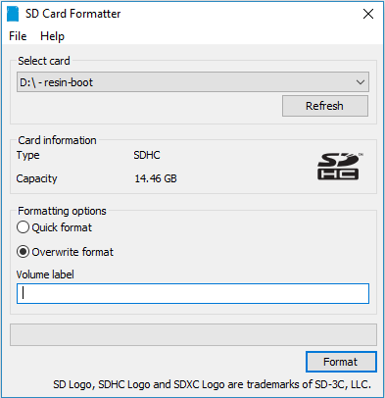

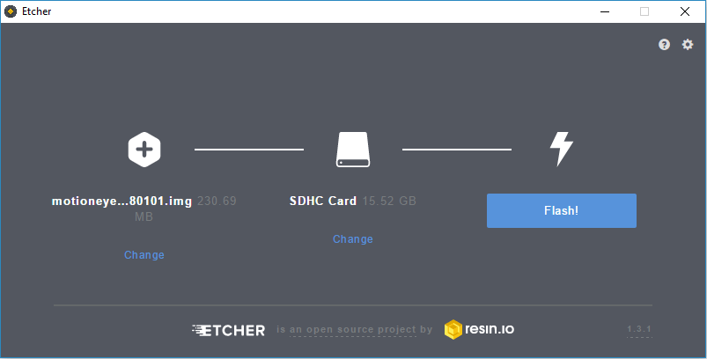

When the flash is completed, your microSD card is ready!

Booting MotionEye on Raspberry Pi
Follow the next steps to boot MotionEyeOS for the first time on your Raspberry Pi.
1. Insert the microSD card in the Raspberry Pi;
2. Connect an Ethernet cable – this is needed on the first boot;
3. Connect a camera. If you’re using the Raspberry Pi camera V2 module, make sure you’ve connected the camera in the right orientation as shown in the following image;
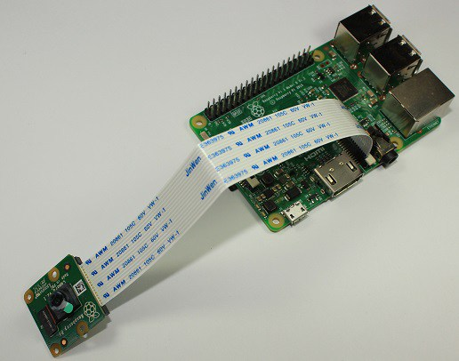
4. Apply power to your Pi, and wait for about 2 minutes for the system to be ready.
Now, to access your Raspberry Pi, you need to find your Pi’s IP Address

Finding Your Raspberry Pi IP Address
To Find your Raspberry Pi IP address, you can use Angry IP Scanner. The IP you’re looking for is the one with “meye” on the name, as shown in the following figure.
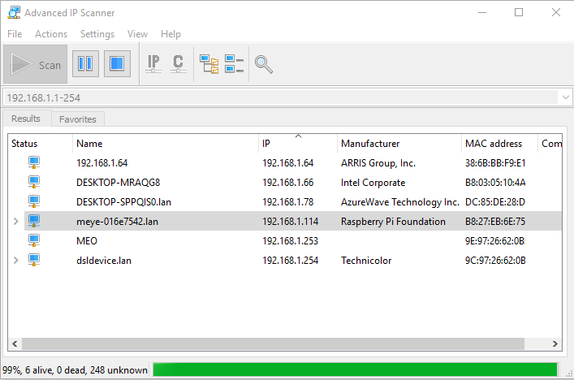

Accessing MotionEye For the First Time
Open your browser and type the Raspberry Pi IP address. You’ll see the MotionEye login page.
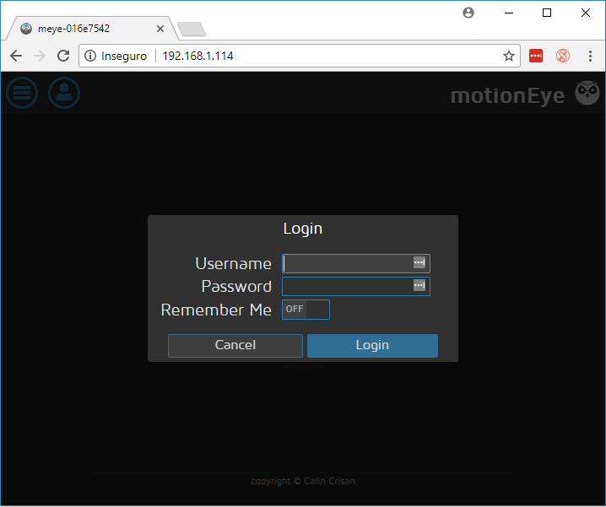
At the first boot, use the following credentials:
- Username: admin
- Password: [No password, leave blank]
If you have a camera connected to your Pi, it should be detected automatically, and you should see a live image from the camera. We’ve connected two cameras, an USB camera, and the Raspberry Pi Camera V2 module, and it automatically shows live image from both.

Initial Setup
You can configure pretty much everything in your web user interface. We recommend taking a look at the following configurations when configuring the MotionEyeOS for the first time.
- Go to the three bars menu, and open the General Settings;
- Enable Advanced Settings;
- You can change the admin username and set a password;
- You can also set a name for a surveillance user, and its corresponding password;
- Set your timezone and a hostname.
Click the orange button at the top right “Apply” to apply the changes – this will require a reboot.
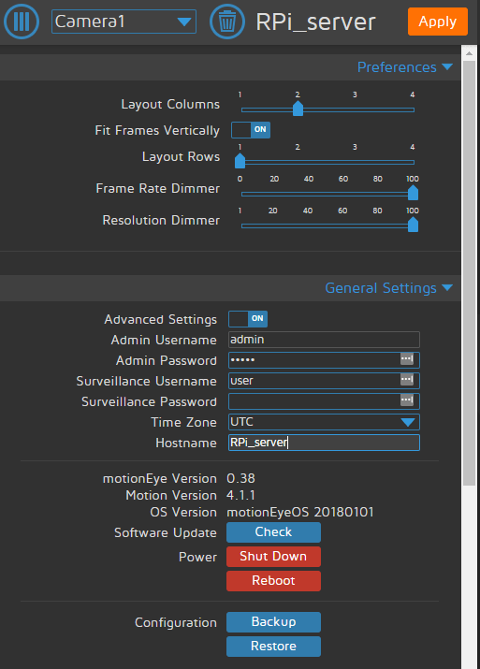
You can also enable Wireless Network in the Network menu. You need to enter your network credentials as shown in the following figure.
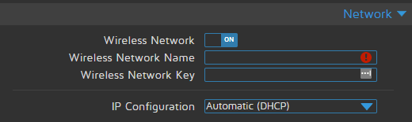
The software is intuitive to use. Take a look at the menus and see what they can do.

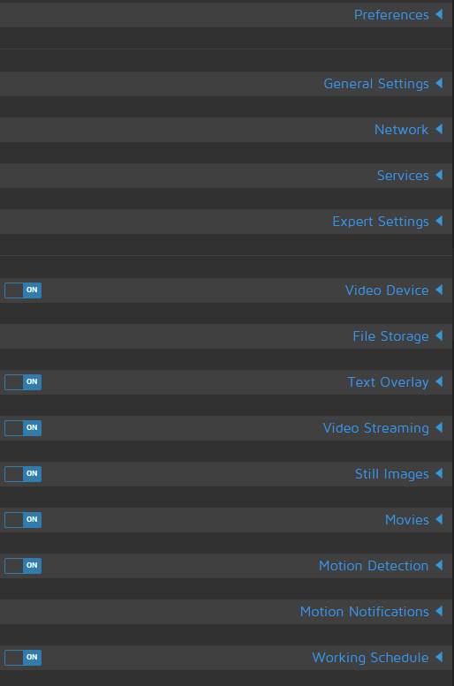

wpa_supplicant.conf:
country=IN
ctrl_interface=DIR=/var/run/wpa_supplicant GROUP=netdev
update_config=1
network={
ssid="wifi_name"
psk="wifi_password"
key_mgmt=WPA-PSK
}
Note: This wpa_supplicant.conf has to be pasted in SD Card to make raspberry pi detect and connecting to the WIFI automatically.

Structure diagram:

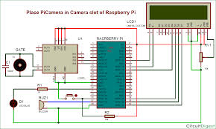

Output:

The Motion Triggered(Motion captured) Image and Video Sent to Given Email

